**Object-Oriented Design II**

SSE 554

Dr. MacNeil

Spring 2017

**Project II**

Brent Bitler

Matthew Robison

Table of Contents

Table of Contents 2

Table of Figures 4

Introduction 5

Purpose 5

ASP.net MVC Breakdown 6

Overview 6

Quick Start App 7

Overview 7

App & Request Life Cycle 9

Overview 9

Application Life Cycle 9

Request Life Cycle 9

Routing & Controllers 11

Overview 11

Actions 14

Filters 16

Selectors 17

ActionName 17

NonAction 17

ActionVerbs 18

Views 20

Application Creation 21

Data Model 21

Helpers 21

Model Binding 21

Databases 21

Validation 21

Caching 21

Unit Tests 21

Appendix 22

HomeController.cs 22

RouteConfig.cs 22

ProcessController.cs 23

UserController.cs 23

AdminController.cs 24

HomeController.cs (with Redirection) 24

HomeController.cs (with GetCurrentTime) 24

HomeController.cs (with Action and NonAction Selectors) 25

UserController.cs (with ActionVerbs) 26

Bibliography 27

Activity Log - Bitler 28

Activity Log - Robison 29

Table of Figures

Figure 1. MVC desgign flow 6

Figure 2. Initial debug with no code implemented 7

Figure 3. Initial default controller added with test output text 7

Figure 4. 404 error resolved 8

Figure 5. MVC Request Life Cycle flow chart 10

Figure 6. RouteConfig class with RegisterRoutes method 11

Figure 7. Home/Index provides same URL as before 12

Figure 8. Process page output 12

Figure 9. Global.asax Application_Start method 13

Figure 10. User route added with search action 13

Figure 11. UserController class 13

Figure 12. Action functionality output 13

Figure 13. AdminController returns string of admins 14

Figure 14. Output of admin controller access 15

Figure 15. RedirectToAction method utilization 15

Figure 16. Two action filters applied for caching purposes 16

Figure 17. Current time cached for 10 seconds until page refresh 16

Figure 18. Current time utilizing ActionName 17

Figure 19. NonAction in use 18

Figure 20. Output of NonAction 18

Figure 21. 404 error when attempting to accessing timeAsString as an action 18

Figure 22. ActionVerb in use 19

Figure 23. ActionVerb output with HTTP Get 19

Introduction

## Purpose

For Project II, the purpose was to choose a topic new to us from the text, demonstrate our capabilities through software design, coding, and finally unit testing while using some form of source control. For Project II, we have decided to investigate ASP.net MVC, its functionality, and implementation by creating several mini sample webpages demonstrating our capabilities per the project requirements on the syllabus. This report will chronicle our design strategy and timeline. The features of the project requirements are outlined in the table below.

Table 1. Project II Composition

|  |  |
| --- | --- |
| Team Composition | Brent Bitler, Matthew Robison |
| Topic | ASP.net MVC |
| Distributed Version Control System | GitHub |
| Programming Language | C# |
| IDE | Visual Studio 2015 |
| TDD Tool | Built-in VS unit test tool |

ASP.net MVC Breakdown

## Overview

ASP.net MVC is a framework designed by Microsoft to facilitate website development, utilizing MVC (Model View Controller) methodologies. The benefit here lies in keeping tasks decoupled and provides a clean separation between the three ideologies. The design pattern of MVC is illustrated in figure 1. It is not a standalone venture, but rather was built on top of ASP.net so developers like us are still able to utilize pre-existing ASP.net functionality.

MODEL

CONTROLLER

VIEW

Figure 1. MVC desgign flow

The model is the collection of classes in control of the data aspect of the program. The view, as its name hints towards, helps manage the user experience through the UI (User Interface) and is in HTML (Hypertext Mark-up Language). The controller is the collection of classes that deals with user interaction and application conditionals and logic. The rest of this report will chronicle the implementation of an ASP.net MVC application from start to finish.

Quick Start App

## Overview

The first step of the application process is to utilize the Visual Studio IDE to begin creating our webpage. We began by selecting an empty ASP.net 4.5.2 template and addings references for MVC. This will provide us with a blank slate for development with minimal predefined content. Here is the starting point for our program after a quick launch. Obviously, we expect a connection error as we have no defined any code thus far.

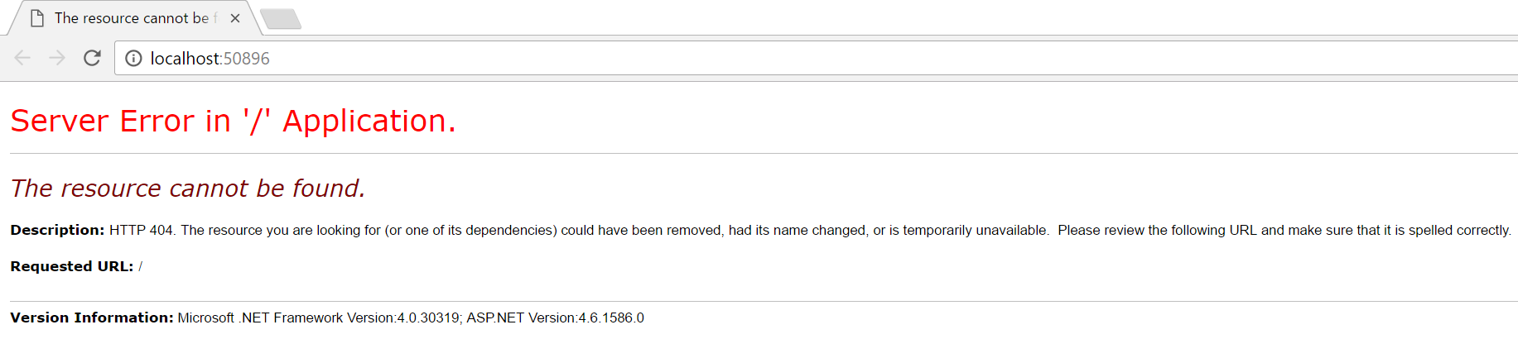

Figure 2. Initial debug with no code implemented

This will change shortly after adding a controller to the application as shown in figure 3 with a string test output.

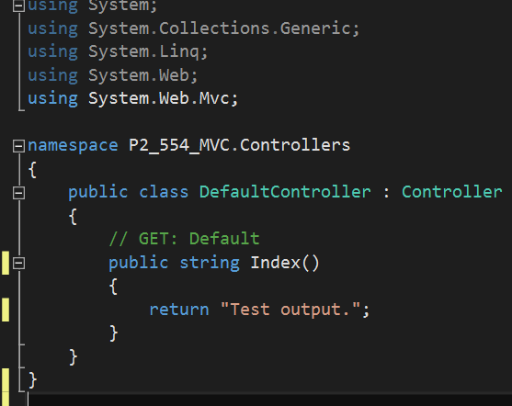

Figure 3. Initial default controller added with test output text

Now if we run the application we have an established connection with the resulting output shown in figure 4.

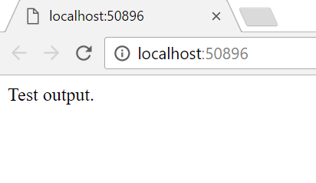

Figure 4. 404 error resolved

App & Request Life Cycle

## Overview

A life cycle, in general, is a grouping of steps are tasks utilized to handle some sort of request to change the state of an application. The input is a request while the output is a response. In general, MVC consists of two life cycles [1]:

* Application life cycle
* Request life cycle

## Application Life Cycle

The application life cycle is simple the time the application process begins running until the time it stops. Within this timeframe, numerous request life cycles are able to take place to facilitate the application life cycle.

## Request Life Cycle

The other half of this spectrum is the request life cycle, which is the series of events that occurs when an HTTP request is processed by the application. The request is then routed thorugh the URL Routing Module, which is a .NET component able to latch into the application. From here, the MVC framework converts the routing data into a controller able to process requests. At this point, an action invoker searches for and chooses the correct Action method to invoke the controller [1].

This can be seen as the rebound point for the flow diagram seen in figure 5, which fires off Result Execution. Depending on the type of output it will either be a View engine and subsequently render the view, otherwise the action result will execute on its own. This is what capitulates a real response to the initial HTTP request.

Routing

View Engine

Result Execution

Controller Initialization

Action Execution

Result Execution

RESP

REQ

Figure 5. MVC Request Life Cycle flow chart

Routing & Controllers

## Overview

This is the mechanism of tunneling an HTTP request to a controller, handled in the System.Web.Routing assembly. A default template is loading to an MVC project in the form of a Global.asax file. This file utilizes an implementation of the RouteConfig class, with a very useful RegisterRoutes method as seen in figure 6.

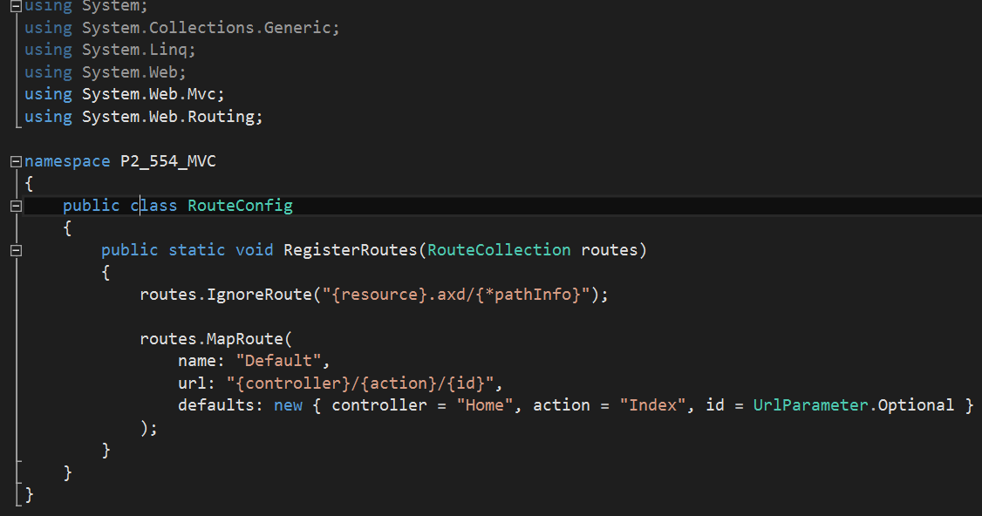

Figure 6. RouteConfig class with RegisterRoutes method

Routes will be defined by us, which then have URLs mapped to the designated controller action. URLs are defined by the notation {controller name}/{action name}/{id name}. The Visual Studio IDE generates a random port number for the application. In our instance, 50896 was utilized. Any time a browser requests <http://(ourwebpage)/Home> it returns the output from the Index method of HomeController. Utilizing the same URL with /Home or /Home/Index will yield the same output as before with this test output. This is shown in figure 7.

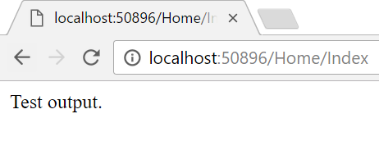

Figure 7. Home/Index provides same URL as before

Additionally, we can create a custom process controller with a custom convention as opposed to this predefined nomenclature by adding a new controller. The default action will be List instead of Index. The result from the ProcessController is displayed in figure 8.

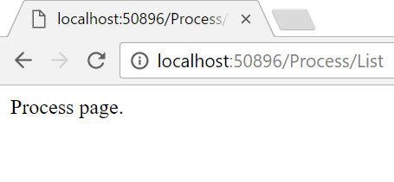

Figure 8. Process page output

Let us change some code to better explain controllers in more detail. Figure 9 shows the creation of a UserController with updated Global.asax code functionality while figure 10 illustrates the updated implemention of the RouteConfig class, so someone browsing can input the URL “User/Brent” with Brent as the parameter name and not an Action method. The UserController class reflects this functionality in figure 11. Because the parameter is added to the Action method, the MVC framework is built to search for the value matching the parameter name. The Server.HtmlEncode method converts any malicious code in plain text. The resulting code when run after requesting <http://localhost:50896/User/Brent> returns the result in figure 12.

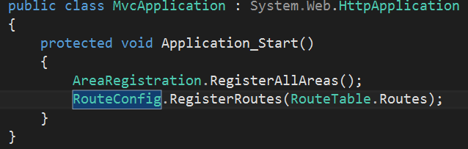

Figure 9. Global.asax Application_Start method

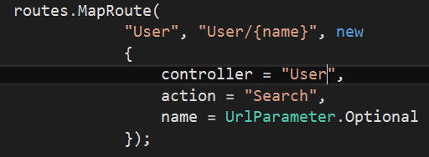

Figure 10. User route added with search action

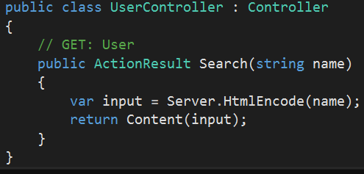

Figure 11. UserController class

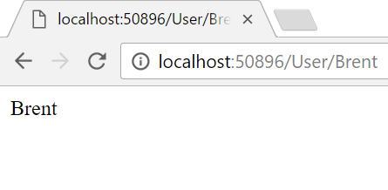

Figure 12. Action functionality output

Actions

Action methods are in charge of pushing requests creating responses to them in the form of ActionResults. A good note here is action methods have to be instantiated and cannot be static, but they can return anything such as a string, integer, Boolean, etc. When a URL is received, the UrlRoutingModule moves it along to the MVC route handler based on the information provided in the routing table. The MVC route handler then moves it along to the MVC handler, which is an HTTP handler. The MVC handler instantiates the controller by utilizing the RouteData for the controller value through virtue of the IController Interface. The method that executes creates an action invoker, which looks in the RouteData and locates the action parameter sent from the routing engine.

The UserController was already established previously. We will continue this mini example by creating an AdminController. Through adding the list of administrators to the Controller as seen in figure 13, by accessing the URL <http://localhost:50896/Admin/GetAllAdmins>, the method returns the list of admins as shown in figure 14. Furthermore, we are able to utilize the RedirectToAction method with two inputs action name and controller name to redirect from a controller to another as shown in figure 15, yielding the same output, again, as figure 14.

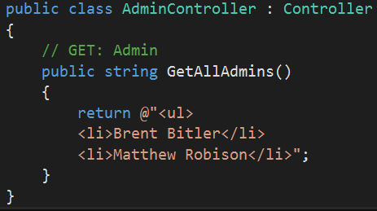

Figure 13. AdminController returns string of admins

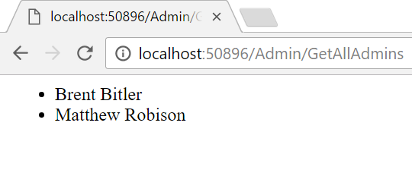

Figure 14. Output of admin controller access

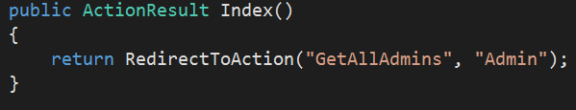

Figure 15. RedirectToAction method utilization

Filters

As we now know, controllers help define action methods with a one-to-one correspondence with user interactions; however, filters allow us as programmers to execute logic before and/or after an action method is executed. There are four unique types of filters and are executed based on the priority ordering below [2]:

1. Authorization filter – work with authentication and authorization
2. Action filter – wrap the action method execution
3. Result filter – wrap execution of the ActionResult object
4. Exception filter – executes if there is an unhandled exception thrown, useful for logging or displaying error pages

Here, we will implement two action filters. The first will be applied to the Index() action and will cache its return value for 5 seconds. By adding the GetCurrentTime method as seen in figure 16 with a duration of 10 seconds, when we navigate to <http://localhost:50896/Home/GetCurrentTime>, the value displayed will hold until 10 seconds have passed and the page is refreshed as shown in figure 17. 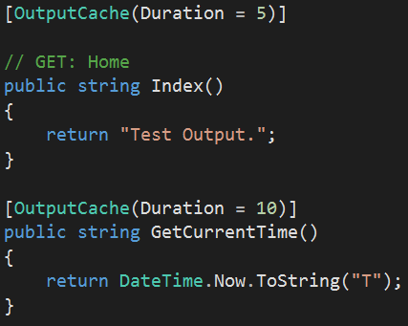

Figure 16. Two action filters applied for caching purposes

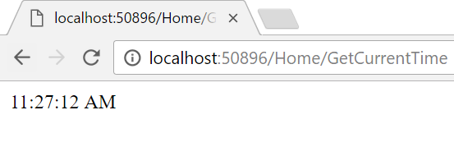

Figure 17. Current time cached for 10 seconds until page refresh

Selectors

Selectors help dictate what particular action method is invoked following a request and can be broken down into three categories:

1. ActionName
2. NonAction
3. ActionVerbs

## ActionName

The action name class allows us as software developers to utilize an action name different from the method name. We can continue utilizing the previous example to drive this point home by inserting the line [ActionName(“currTime”)] directly before the GetCurrentTime method. Doing so in coordination to navigating to the URL <http://localhost:50896/Home/currTime> will yield the following output page as shown in figure 18.

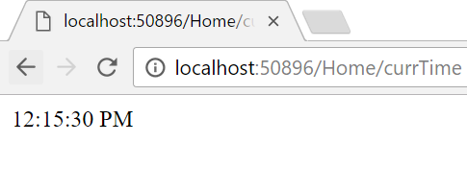

Figure 18. Current time utilizing ActionName

## NonAction

NonAction is fairly self-explanatory. This built in attribute is useful when one does not desire a method to be treated as if it were an action method and an example is shown in figure 19 with its output in figure 20 by navigating to <http://localhost:50896/Home/currTime> again. However, using timeAsString as an action will yield a 404 error as shown in figure 21.

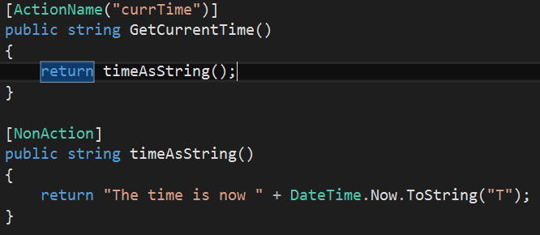

Figure 19. NonAction in use

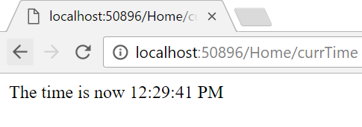

Figure 20. Output of NonAction

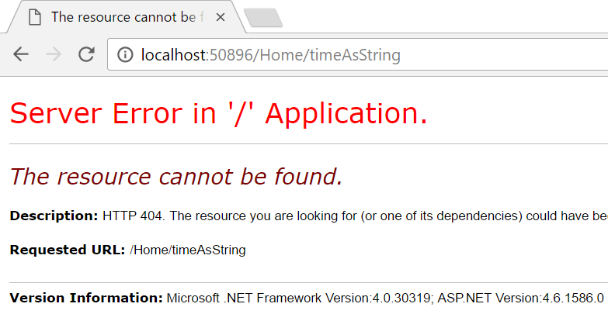

Figure 21. 404 error when attempting to accessing timeAsString as an action

## ActionVerbs

ActionVerbs help restrict a specific action to certain HttpVerbs. This allows us as developers to define two action methods with the same exact name, but one action will be responsible for responding to an HTTP Get requiest while the other will be responsible for respoding an HTTP Post request. This demonstrated with code in figure 22 and the corresponding output in figure 23 through updates to our previously defined UserController class.

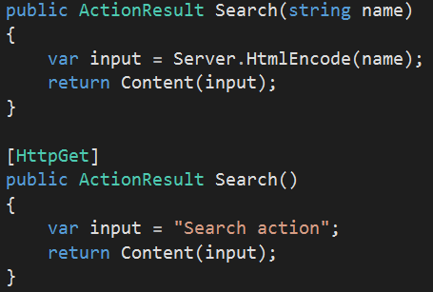

Figure 22. ActionVerb in use

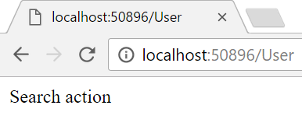

Figure 23. ActionVerb output with HTTP Get

Views

Application Creation

## Data Model

## Helpers

## Model Binding

## Databases

## Validation

## Caching

## Unit Tests

Appendix

## HomeController.cs

namespace P2_554_MVC.Controllers

{

public class HomeController : Controller

{

// GET: Home

public string Index()

{

return "Test Output.";

}

}

}

## RouteConfig.cs

using System;

using System.Collections.Generic;

using System.Linq;

using System.Web;

using System.Web.Mvc;

using System.Web.Routing;

namespace P2_554_MVC

{

public class RouteConfig

{

public static void RegisterRoutes(RouteCollection routes)

{

routes.IgnoreRoute("{resource}.axd/{*pathInfo}");

routes.MapRoute(

"Process", "Process/{action}/{id}",

defaults: new

{

controller = "Process",

action = "List",

id =

UrlParameter.Optional

});

routes.MapRoute(

"User", "User/{name}", new

{

controller = "User",

action = "Search",

name = UrlParameter.Optional

});

routes.MapRoute(

name: "Default", url: "{controller}/{action}/{id}", defaults: new

{

controller = "Home",

action = "Index",

id = UrlParameter.Optional

});

}

}

}

## ProcessController.cs

using System;

using System.Collections.Generic;

using System.Linq;

using System.Web;

using System.Web.Mvc;

namespace P2_554_MVC.Controllers

{

public class ProcessController : Controller

{

// GET: Process

public string List()

{

return "Process page.";

}

}

}

## UserController.cs

using System;

using System.Collections.Generic;

using System.Linq;

using System.Web;

using System.Web.Mvc;

namespace P2_554_MVC.Controllers

{

public class UserController : Controller

{

// GET: User

public ActionResult Search(string name)

{

var input = Server.HtmlEncode(name);

return Content(input);

}

}

}

## AdminController.cs

using System;

using System.Collections.Generic;

using System.Linq;

using System.Web;

using System.Web.Mvc;

namespace P2_554_MVC.Controllers

{

public class AdminController : Controller

{

// GET: Admin

public string GetAllAdmins()

{

return @"<ul>

<li>Brent Bitler</li>

<li>Matthew Robison</li>";

}

}

}

## HomeController.cs (with Redirection)

using System;

using System.Collections.Generic;

using System.Linq;

using System.Web;

using System.Web.Mvc;

namespace P2_554_MVC.Controllers

{

public class HomeController : Controller

{

// GET: Home

public ActionResult Index()

{

return RedirectToAction("GetAllAdmins", "Admin");

}

}

}

## HomeController.cs (with GetCurrentTime)

using System;

using System.Collections.Generic;

using System.Linq;

using System.Web;

using System.Web.Mvc;

namespace P2_554_MVC.Controllers

{

public class HomeController : Controller

{

[OutputCache(Duration = 5)]

// GET: Home

public string Index()

{

return "Test Output.";

}

[OutputCache(Duration = 10)]

public string GetCurrentTime()

{

return DateTime.Now.ToString("T");

}

}

}

## HomeController.cs (with Action and NonAction Selectors)

using System;

using System.Collections.Generic;

using System.Linq;

using System.Web;

using System.Web.Mvc;

namespace P2_554_MVC.Controllers

{

public class HomeController : Controller

{

// GET: Home

public string Index()

{

return "Test Output.";

}

[ActionName("currTime")]

public string GetCurrentTime()

{

return timeAsString();

}

[NonAction]

public string timeAsString()

{

return "The time is now " + DateTime.Now.ToString("T");

}

}

}

## UserController.cs (with ActionVerbs)

using System;

using System.Collections.Generic;

using System.Linq;

using System.Web;

using System.Web.Mvc;

namespace P2_554_MVC.Controllers

{

public class UserController : Controller

{

// GET: User

public ActionResult Search(string name)

{

var input = Server.HtmlEncode(name);

return Content(input);

}

[HttpGet]

public ActionResult Search()

{

var input = "Search action";

return Content(input);

}

}

}

Bibliography

[1] Engelbrecht, Andries P. *Computational Intelligence: An Introduction, (2nd ed.)*. Wiley, 2007.

[2] https://msdn.microsoft.com/en-us/library/gg416513(VS.98).aspx

Activity Log - Bitler

|  |  |  |
| --- | --- | --- |
| Date | Time (mins) | Description |
| 1/9/17 | 60 | Looked through Naïve GA |
| 1/10/17 | 60 | Looked through and worked Naïve GA |
| 1/11/17 |  |  |
| 1/12/17 | 120 | Research GA’s online for topic ideas |
| 1/13/17 | 180 | Read Ch 9 - GA |
| 1/14/17 | 90 | Read Ch 9 - GA |
| 1/15/17 |  |  |
| 1/16/17 | 120 | Begin constructing class structure of string unscramble program |
| 1/17/17 | 120 | Begin chromosome class |
| 1/18/17 | 120 | Continue working chromosome class, begin developing population class |
| 1/19/17 |  |  |
| 1/20/17 |  |  |
| 1/21/17 | 60 | Finish chromosome class |
| 1/22/17 | 240 | Continue working population class |
| 1/23/17 | 120 | Connector class |
| 1/24/17 | 30 | Come up with initial variable settings |
| 1/25/17 |  |  |
| 1/26/17 | 240 | Begin generating report |
| 1/27/17 | 180 | Put together test data |
| 1/28/17 | 360 | Conclude paper, graphs, etc |
| 1/29/17 | 180 | Final review of paper |
| 1/30/17 | 15 | Submit paper |
|  |  |  |
| TOTAL | 2295 |  |

Activity Log - Robison